# CS 255 System Design Document Template

## UML Diagrams

### UML Use Case Diagram

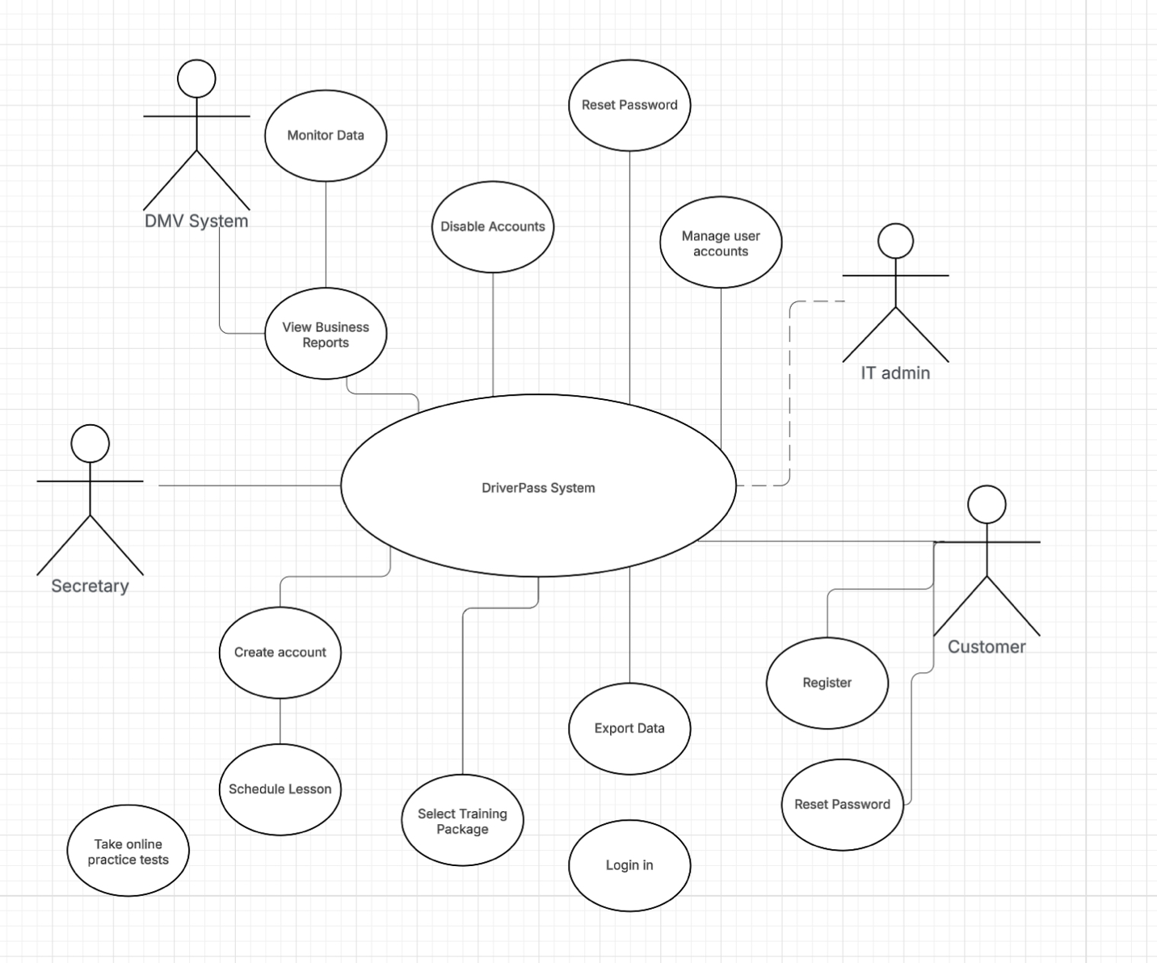

### UML Activity Diagrams

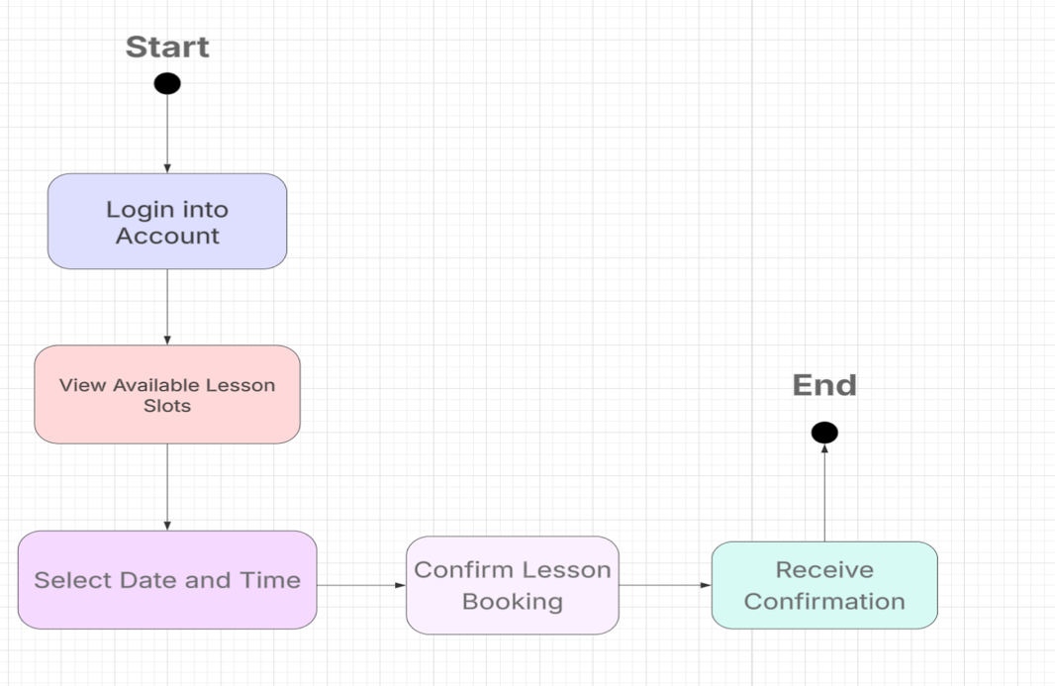

### UML Sequence Diagram

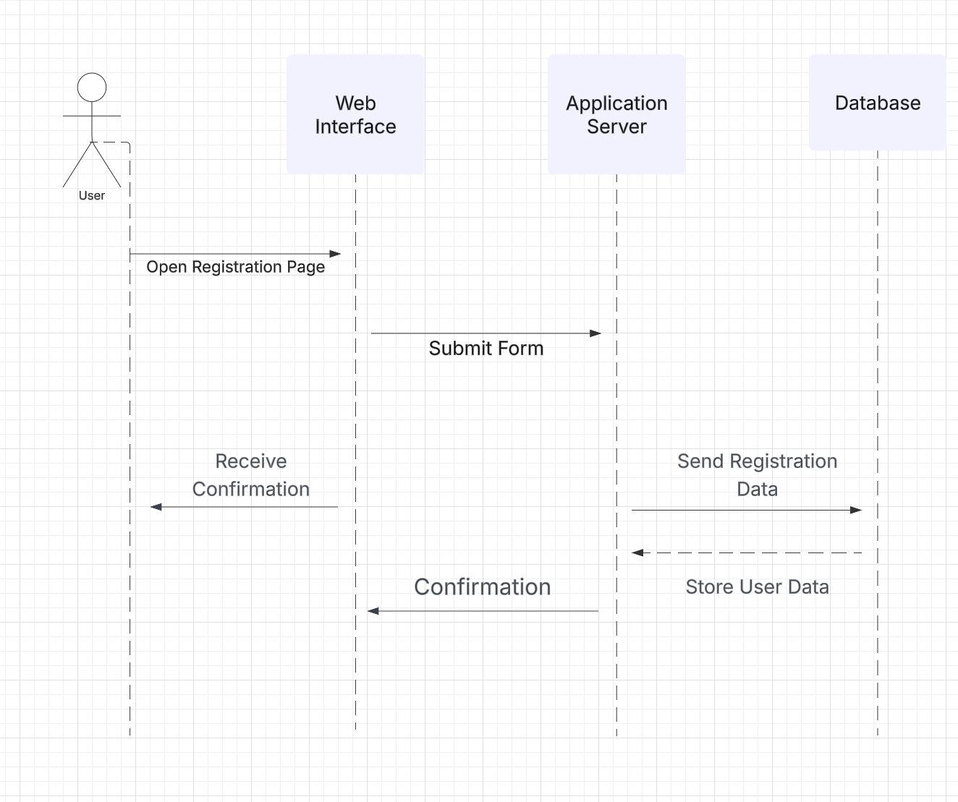

### UML Class Diagram

## Technical Requirements

For the DriverPass software to support multiple users at once, a secure web server with lots of memory and processing power is required. For storing user, lesson, and test data, it will require a database such as MySQL or PostgreSQL. To ensure that it functions well on desktops and smartphones, the website will be developed with HTML, CSS, and JavaScript in addition to a framework like React.Either Python (such as Flask or Django) or Node.js will be used for the back end. In addition to user roles and login security, it will be combined with DMV data for updating. We'll use some tools like Lucid chart (diagrams), Git (code version management), and Postman (testing).